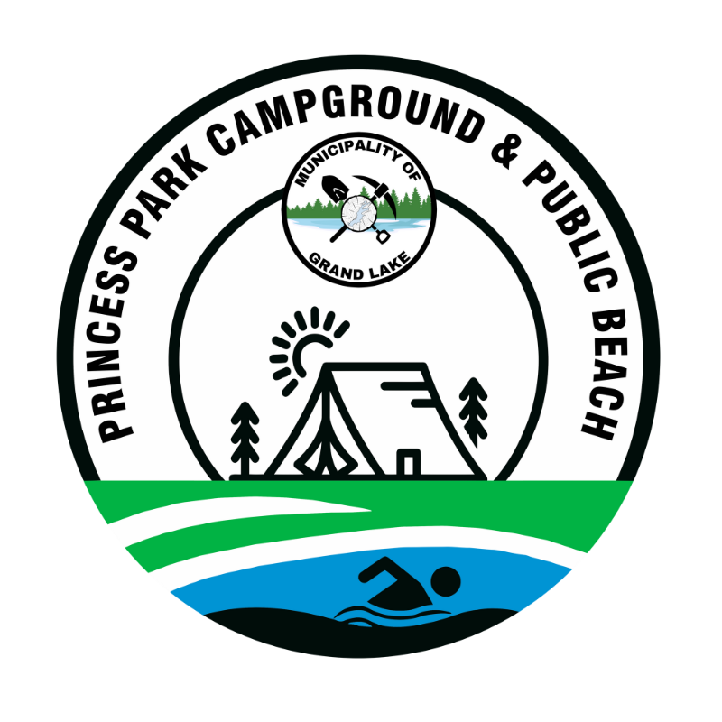

Princess Park Campground

Municipality of Grand Lake (MOGL)

PET REGISTRATION & AGREEMENT FORM 2026
Camper’s Information:
Camper Name: _______________________________ Lot #: ___________________
Phone: ___________________ Date: _______________________

Pet’s Information:
Pet Name: _____________________________ Breed: __________________________
Color/Description: _______________________________
Rabies Certificate Expiry Date: ___________________
☐ Copy of current Rabies Certificate attached
☐ Current municipal/provincial tags verified

Pet Rules & Regulations
By signing below, I acknowledge and agree to the following campground pet policies:
- Vaccination & Tags
- Proof of a current rabies vaccination certificate is required.
- Pet must wear current registration/license tags at all times.
- Leash & Confinement
- Pets must be confined to the camper’s lot and kept on a leash at all times, whether on the lot or while walking within the campground.
- A railing up to three (3) feet high around a deck is permitted for the purpose of pet confinement.
- Restricted Areas
- Pets are not permitted on the beach.
- Pets are not permitted in picnic areas.
- Noise Control
- Dogs that bark excessively or continuously and disturb other campers will not be permitted.
- Pet owners must ensure their animals do not create a nuisance through excessive barking, whining, or aggressive behavior.
- Failure to control excessive noise may result in warnings, fines, or removal of the pet from the campground.

- Waste Disposal
- All animal excrement must be picked up immediately and properly disposed of.

- Fines & Enforcement
- A initial fine of $200.00 will be imposed on any seasonal camper/pet owner who fails to clean up after their pet.
- Continued non-compliance may result in additional fines and/or eviction from the campground.
- Day-use visitors who fail to clean up after their pet will be evicted immediately.
Signatures:
Issued By: _______________________________ Date: _________________
Signature: _______________________________ Date: _________________

