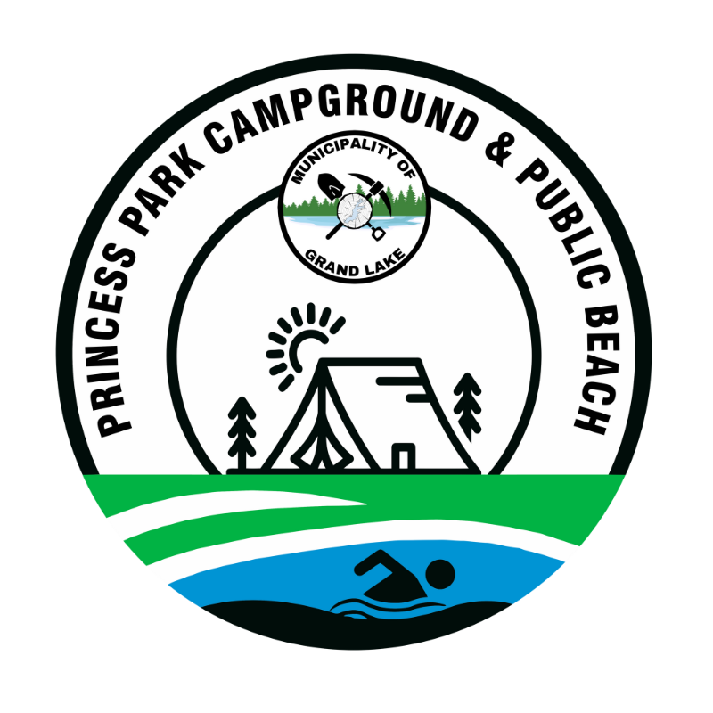

Princess Park Campground

Municipality of Grand Lake (MOGL)
Cancellation Policy & Refund Policy
Our CANCELLATION POLICY is as follows:
- Cancellations made more than 10 days prior to the date of the reservation will be offered: a refund, less a $50 processing fee, or a full campground credit good for 1 year from the date of cancellation.

- Cancellations within or less than 14 days of the date of the reservation will be offered a full campground credit.

- Cancellations of Holiday Weekend reservations (Victoria Day, Canada Day, New Brunswick Day, and Labor Day) less than 10 days prior to the date of reservation, are not eligible for a refund or campground credit.

- Cancellations within 72 hours of reservation are not eligible for a refund or campground credit.

- Reservations will not be offered a refund or campground credit for early departures.

- Weather related cancellations or departures are not eligible for a refund or campground credit.

- Seasonal site cancellations prior to April 1 will be refunded, less deposit, or less 31 days camping fees, whichever is greater.

Our REFUND POLICY is as follows:
- Site deposit fees (fees paid to reserve seasonal sites for the next campground season) are NON-REFUNDABLE, NON-TRANSFERABLE for any reason.

CAMPER NAME: CAMP SITE #:
DATE:
DURATION OF STAY:

